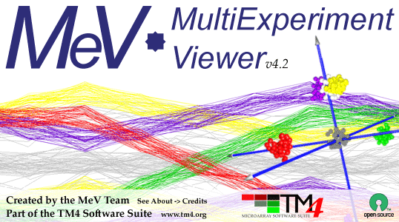
MeV nEASE tutorial

Downloading and Running MeV
MeV for Windows and Linux requires Java v1.6 or higher to run. MeV for Mac OSX requires Java v1.5 or higher. Download the Java Runtime Environment from http://java.sun.com/ and install it before proceeding with this tutorial.

Download the appropriate version of nEASE-MeV for your operating system from http://www.tm4.org/mev_nease.html. Unzip the downloaded file with Winzip or another unzipping tool. To run MeV on Windows, double-click tmev.bat. To run MeV on Linux/Unix, run tmev.sh. To run MeV on MacOSX, double-click on the MeV application icon.

Loading Data
When you launch MeV, two windows will open. The small narrow window across the top of the screen is called the MeV main menubar. This window is used normally to open new MultipleArrayViewer windows and manage other MeV properties. We will not be using this menubar window for the purposes of this tutorial. The larger window that opens is called a MultipleArrayViewer (MAV). This is where the majority of our work will take place.

Choose File-> Open Analysis from the MAV window. In the file chooser that opens, navigate to the folder that contains MeV, and open the folder called Data. Please select the file miller_er.anl and choose Open. A saved analysis will be loaded into MeV. This may take some time. These data and the other data files found in the MeV-nEASE package are described more fully in the manuscript.

This analysis is based on the data from Miller et al. (2005) and Minn et al. (2005) and contains N samples. It is further described in the manuscript. Four other analysis files are also available, containing the additional data sets described in the analysis. These should be visible in the main view. Along the left-hand side of the MAV window is a result tree. As you create results in MeV, new icons will appear in this window. Double-clicking on these icons will reveal the result viewers for these analyses.

Running Nested EASE
Near the top of the MAV is a row of colorful drop-down menus. These menus contain the analysis options available in MeV. Click the Meta-Analysis drop-down menu, and select EASE. An initialization dialog will appear.

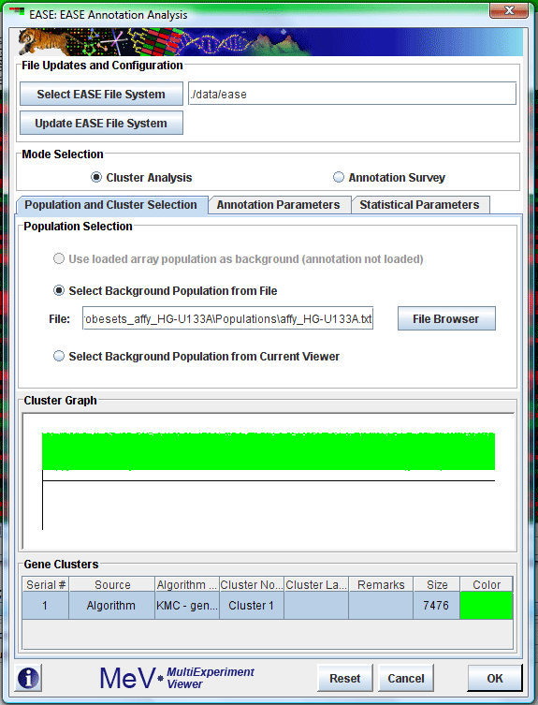
This dialog contains three tabs.
Tab 1: Population and Cluster Selection
Make sure the option Select Background Population from File is selected. Click the button labeled File Browser and select the file mev_home\data\ease\Lists\Probesets_affy_HG-U133A\Populations\affy_HG-U133A.txt.

Tab 2: Annotation Parameters
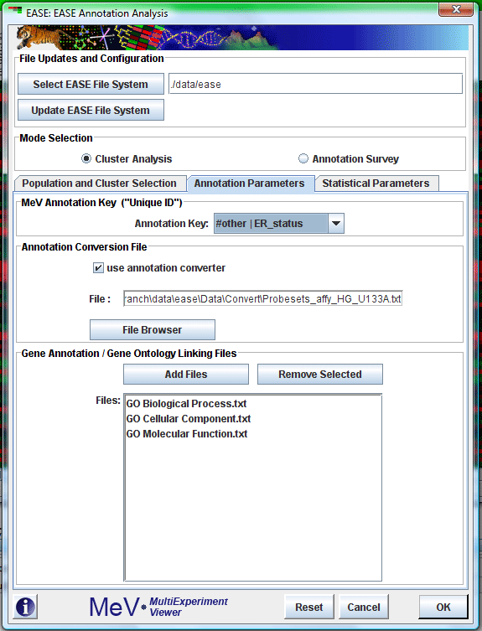
From the drop-down menu labeled Annotation Key, select the heading #other | ER status. Click the checkbox labeled use annotation converter. Click the button labeled File Browser and select the file mev_home\data\ease\Data\Convert\Probesets_affy_HG_U133A.txt. In the lower half of the tab, under the heading Gene Annotation/ Gene Ontology Linking Files click the Add Files button. Use shift-click to select the three files from the mev_home\data\ease\Data\Class directory, GO Biological Process.txt, GO Molecular Function.txt and GO Cellular Component.txt. Click Open.

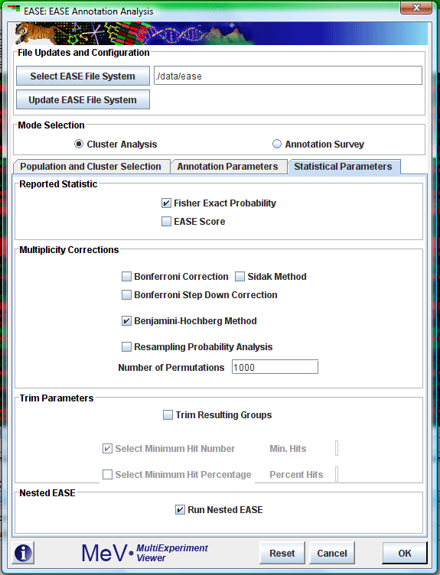
Tab 3: Statistical Parameters
Click to select the check box next to Run Nested EASE, near the bottom of the tab. Check the box labeled Benjamini-Hochberg Method.

Now click the Ok button at the bottom of the initialization dialog to run EASE.

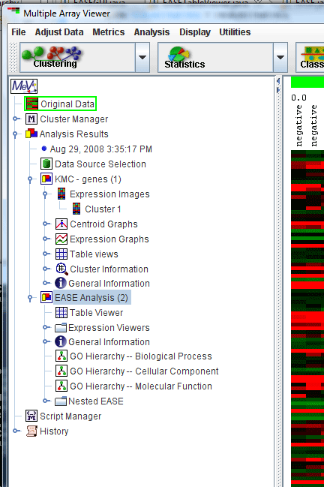
Viewing the nEASE results
The standard EASE analysis, as described Hosack, et al. (2003), will run, followed by the Nested EASE analysis. The nEASE results are included with the standard EASE results, as a subnode on the result tree, labeled Nested EASE. Double-click the result node labeled EASE Analysis (2) to see the nested ease results appear.

We recommend that you expand the size of the window containing the Result Tree by clicking and dragging on the dividing bar between the Result Tree and the larger viewing window on the right.

Click on the result nodes to explore the result data within. The most useful view is found in a node labeled Nested EASE Summary Table, which contains the summarized data for all of the nEASE results. This is the data reported in the paper.

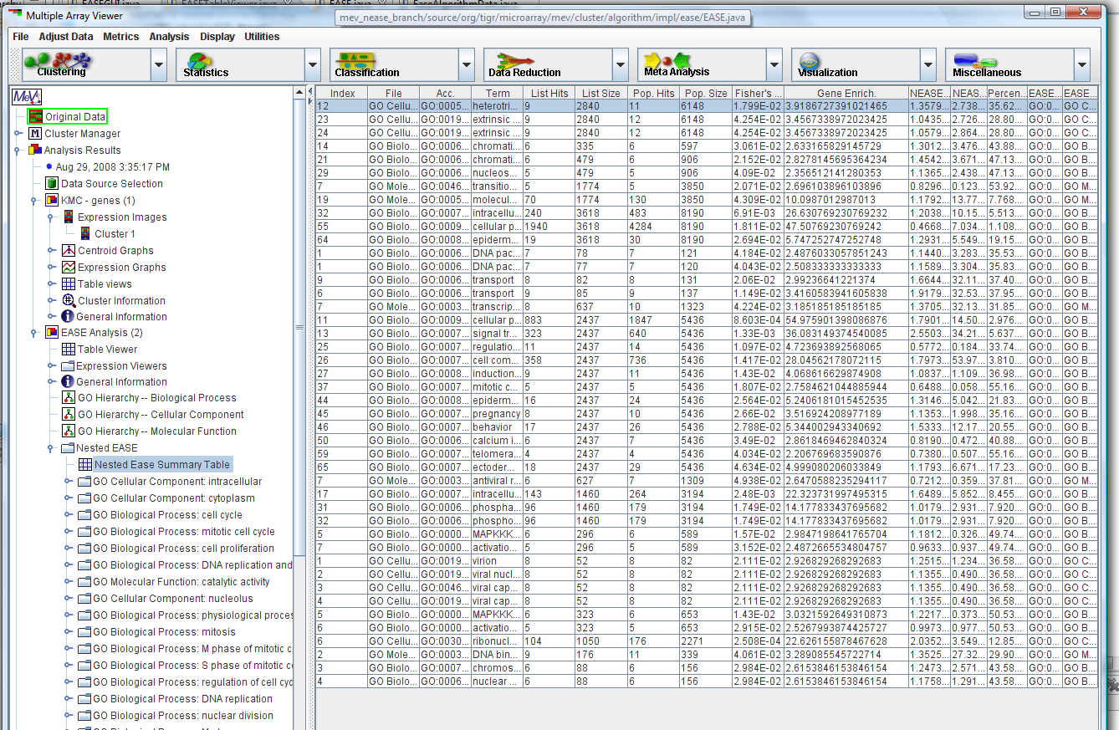
References
D. A. Hosack, G. Dennis, B. T. Sherman, H. C. Lane, R. A. Lempicki, Genome Biol 4 (2003).
A. J. Minn, et al. , Nature 436, 518. (2005)
L. D. Miller, et al. , Proceedings of the National Academy of Sciences 102, 13550 (2005).

